Does the Home Run Derby Change How Hitters Hit? A Matched-Comparison Study of Batted-Ball Approach
Jack Rollo
Denison University
November 4th, 2026
Abstract
Fans and analysts have long speculated that participating in Major League Baseball's Home Run Derby changes how hitters perform after the All-Star break, but prior research has focused on performance and injury rather than on hitters' approach. This study examined whether Derby participation is associated with a shift toward a pull-oriented, fly-ball-heavy batted-ball profile. Eighty-five eligible participant-seasons from 2015–2019 and 2021–2026 were matched one-to-one with non-participating All-Stars from the same season using Mahalanobis distance on six first-half Statcast variables, producing 71 matched pairs. The primary outcome was the first-to-second-half change in a Pull-Air Index combining standardized FanGraphs Pull% and FB%. After adjusting for first-half values, participants' index rose 0.11 standard deviations more than their controls', a difference that was not statistically significant (95% CI [−0.08, 0.29], p = .25); the increase came from pulling the ball more rather than hitting more fly balls. Among secondary outcomes, tested at a Bonferroni-corrected α = .025, participants' share of pulled home runs rose 6.9 percentage points more than controls' (97.5% CI [−0.3, 14.1], p = .031), and their HR/FB declined less (p = .049), but neither reached significance, and the home-run result was sensitive to a small number of players with few second-half home runs. Every estimate pointed toward a more pull-oriented approach, but the evidence is consistent with no effect or a modest one and argues against a large change in approach following the Derby.
Introduction
The Major League Baseball (MLB) Home Run Derby is a widely regarded event, having established itself as one of the most highly anticipated annual exhibition events in all sports. There are few plays in sports that can captivate a crowd quite like a home run, and the opportunity to see premium athletes do this in repetition is a special privilege for fans. The Home Run Derby was implemented into MLB’s All-Star Break during the 1985 season, featuring 8 of the most prolific home run hitters in the sport at the time. In 1993, it was broadcast on tape delay, before it was moved to live television in 1998, cementing itself in MLB’s culture.
As the Derby grew in popularity, questions began to arise about its potential influence on participants’ health and performance in the remainder of that season. Fans and critics had observed a decline in the on-field results of some players who had participated, though these claims were not backed by statistical evidence. Regardless, a handful of second-half injuries inflicted upon participants over the years raised additional concerns. While the Derby provides entertainment and an outlet from the repetition of a 162-game MLB season, the players participating are typically young stars who project to be among the game’s best players, or longtime high-level performers who are on lucrative contracts. With the level of investments teams and fans have in these players, it is justifiable to examine these claims further. Given the combination of apparent decreases in on-field output, and the consideration of the body’s ability to handle the force of over one hundred max intent swings throughout the event, research into the subject became more prevalent.
There have been numerous attempts to answer these questions in years since. The idea of a Home Run Derby “curse” was opposed by a 2010 study from Jaiclin and McCollum (2010) claiming a decline could be greater attributed to a player’s regression to the mean, rather than a significant fluctuation in performance. In comparison of 114 participants and 114 non-participating all-stars, DeFroda et. al (2021) found no statistically significant evidence of influence on injury or decline in batting metrics. While there is still a stigma among fans that participation has a negative influence, there are a handful of studies to refute this claim.
What this research has yet to incorporate is batted ball data and potential shifts in a hitter’s approach. The Home Run Derby heavily rewards pulling the ball in the air, as this approach typically elicits the hitter’s maximum power, and the home run fence is shallower and easier to clear when the ball is pulled in comparison to the middle of the field. Pulling the ball requires contact earlier in the pitch's flight, and Giordano et al. (2026) tied contact depth to swing attack angle, while Nakashima et al. (2025) showed the acceptable timing window at impact is only several milliseconds and depends on swing path. If a hitter makes a conscious adjustment to pull the ball in the air more frequently while participating in the Derby, it is reasonable to believe this change in approach may carry over to their typical swing in regular games throughout the remainder of the season.
MLB players are owed millions of dollars annually by their respective teams, and those who participate in the Derby typically hold the top portion of contract values in all sports. If participating in the Derby elicited a significant change in batted-ball profile and approach, it is reasonable for teams and players to consider this potential influence and re-evaluate the prospect of partaking.
Methods
Data and Collection. The data cover 88 Home Run Derby participant-seasons from 2015–2019 and 2021–2026, eight participants in each of 11 Derbies; no Derby was held in 2020. A participant-season is one player's season in a year that player competed, so a player who competed in several Derbies contributes one participant-season for each. Each season was divided at that year's All-Star Game: the first half includes all regular-season games through the All-Star Game date, and the second half includes all regular-season games from the following day through the end of the season. Postseason and exhibition games were excluded.
Three sources were combined. Statcast pitch-level data (Baseball Savant, n.d.), retrieved through the pybaseball package (LeDoux, n.d.), were used to compute the first-half matching variables and to classify the direction of every home run from its recorded landing coordinates. FanGraphs batted-ball splits (FanGraphs, n.d.) provided the outcome measures (Pull%, FB%, and HR/FB) for each half. Because FanGraphs does not permit automated downloads, its Splits Leaderboard was filtered to each half’s date range and copied by hand for every season, covering all hitters with at least 140 plate appearances in that half (22 tables in total). Finally, the MLB Stats API (MLB Advanced Media, n.d.) supplied each season’s All-Star Game roster, which defined the pool of potential controls, and each player’s plate appearances in each half, which determined eligibility.
The control pool consisted of every position player on that season’s All-Star Game active roster who did not participate in the Derby, yielding 373 candidate player-seasons. Because the three sources identify players differently, players were linked across them using the Chadwick Baseball Bureau (n.d.) register rather than by name.
Data were checked at several points. Participants’ hand-entered FanGraphs values were compared against the leaderboard copies, matching exactly on 165 of 174 player-halves; the remaining nine contained entry errors and were corrected. Statcast-derived plate appearances and exit velocities matched the hand-collected participant data exactly, and the participant list was verified against official Derby records, which revealed and corrected an error in the 2015 field.
Matching. Players with at least 150 plate appearances in both halves of a season were considered eligible, resulting in 85 of the dataset’s 88 participants qualifying. Each participant was paired with a non-participating All-Star from the same season (342 candidates, after 31 of the original 373 candidates were ineligible) based on six first-half Statcast variables: Pull% (the percentage of balls in play hit to the batter’s pull side), FB% (the percentage of balls in play classified as fly balls or pop-ups), HR/FB (the percentage of those fly balls that result in a home run), K% (the percentage of plate appearances ending in a strikeout), average exit velocity (the speed of the ball off the bat on balls in play), and average launch angle (the vertical angle at which the ball leaves the bat on balls in play).
Each variable was converted to a z-score using the first-half mean and standard deviation of all eligible players, and the similarity between participant i and candidate j was measured by the Mahalanobis distance (Stuart, 2010):
d(i, j) = √[(xᵢ − xⱼ)ᵀ S⁻¹ (xᵢ − xⱼ)]
where x is a player’s vector of six standardized first-half values and S is the covariance matrix of those variables across all eligible players. Because the differences are weighted by the inverse covariance matrix, variables that move together (such as FB% and launch angle) are not double-counted; if the variables were uncorrelated, the measure would reduce to the ordinary Euclidean distance between the two hitters’ standardized profiles. Within each season, participants and candidates were paired, closest pairs first, and each control was used only once. A pair was accepted only if its distance was at most 2.1, a cutoff set before matching. The cutoff of 2.1 corresponds to the 10th percentile of the distance expected between two randomly selected hitters (2χ² with six degrees of freedom). This was fixed before outcomes were examined and balanced pair similarity against retaining enough pairs for analysis. Under the assumption that the six variables are roughly normally distributed, the squared distance between two randomly selected hitters follows 2χ² with six degrees of freedom, and 2.1 corresponds to its 10th percentile. Accepted pairs were therefore more similar than 90% of random hitter pairs.
This produced 71 matched pairs. Match quality was assessed with the standardized mean difference (SMD) for each matching variable, the difference between the two groups' means divided by their pooled standard deviation:
SMD = (x̄_{D} − x̄_{C}) / √[(s²_{D} + s²_{C}) / 2]
where D denotes Derby participants and C the comparison group. Values below 0.10 indicate good balance and values below 0.25 acceptable balance (Stuart, 2010). Participants without an acceptable match are described in the Results.
Outcome Measures. Outcomes were measured with FanGraphs' versions of Pull%, FB%, and HR/FB for each half. These follow the same definitions as the matching variables but rely on FanGraphs' own batted-ball classifications, so their values differ somewhat from the Statcast measures used for matching. Using a separate source for the outcomes also keeps the data used to form pairs separate from the data used to evaluate them.
The primary outcome is a Pull-Air Index (PAI), which summarizes how strongly a hitter favors pulling the ball and hitting it in the air, the combination that produces the most home runs. Each component was first converted to a z-score, which expresses a value as the number of standard deviations above or below the average hitter:
z = (x − x̄_{H1}) / s_{H1}
where x is a hitter's Pull% or FB% in a given half, and x̄_{H1} and s_{H1} are the first-half mean and standard deviation of that statistic across all 427 eligible player-seasons (Pull%: mean 41.0%, SD 6.4; FB%: mean 38.3%, SD 6.6). The index is the average of the two z-scores:
PAI = (z_{Pull} + z_{FB}) / 2
A value of 0 represents a hitter who pulls and lifts the ball at average rates, and positive values indicate a more pull-oriented, fly-ball-heavy approach. Second-half values were standardized with the same first-half reference statistics rather than re-centered, so a change in the index reflects a real change in the hitter rather than a shift in the league average. The primary outcome is the change from the first half to the second:
ΔPAI = PAI_{H2} − PAI_{H1}
Because the index averages two separate rates, it does not directly measure balls that were both pulled and hit in the air; a hitter who pulls many ground balls and hits fly balls to the opposite field can still score highly. This limitation is revisited in the Discussion.
The secondary outcomes were the changes in HR/FB and in HR Pull%, the share of a hitter's home runs that were pulled. Home-run direction was classified from each home run's Statcast landing coordinates. The coordinates were converted to a spray angle, the horizontal angle of the ball's path measured from straightaway center field, and oriented by the batter's handedness on that pitch so that positive angles point toward the batter's pull side (left field for a right-handed batter). A home run was classified as pulled if its spray angle exceeded 15°, opposite field if it was below −15°, and middle otherwise. To validate this approach, the automated classification was compared with manual coding of participants' home runs from Statcast spray charts: the two agreed on 97.8% of the 2,809 home runs compared, and ±15° produced the highest agreement of the thresholds tested. HR Pull% was computed as pulled home runs divided by classified home runs in each half; the 2.5% of home runs without recorded coordinates were excluded.
Statistical Analysis. The primary analysis compared the change in the Pull-Air Index between the 71 matched participants and their 71 controls using ordinary least squares (OLS) linear regression:
ΔPAI_{i} = β₀ + β₁Derby_{i} + β₂PAI_{H1,i} + β₃K%_{i} + β₄HR/FB_{i} + β₅EV_{i} + β₆LA_{i} + ε_{i}
where Derby_{i} equals 1 for participants and 0 for controls, PAI_{H1} is the player's first-half index, and the remaining terms are the first-half K%, HR/FB, average exit velocity (EV), and average launch angle (LA) used in matching. The coefficient β₁ is the quantity of interest: the estimated difference in the change in the index between a participant and a control with the same first-half profile. Including the first-half index accounts for regression to the mean, the tendency of players with unusually high or low first halves to move back toward their typical level (Barnett et al., 2005), which is a particular concern because Derby participants are selected for exceptional first halves (Jaiclin & McCollum, 2010). The remaining matching variables were included because matching did not fully balance the two groups. The primary outcome was designated before analysis and tested once at α = .05, with a 95% confidence interval for β₁.
The secondary outcomes used the same model, substituting each outcome's change and first-half value for the index. Testing several outcomes increases the chance that at least one appears significant by chance alone: with two tests at α = .05, the probability of at least one false positive rises to nearly 10%. To keep that probability at 5% for the secondary outcomes, the Bonferroni correction divides the significance threshold by the number of tests in the group, giving α = .05 / 2 = .025 per test (Armstrong, 2014). The primary outcome retains α = .05 because it was designated in advance and tested once, and supporting and exploratory analyses were not counted because they are not used to claim an effect. Bonferroni was chosen over less conservative alternatives because it is simple, was specified in the research design, and errs toward avoiding false positives in a modest sample. Secondary results are therefore reported with 97.5% confidence intervals, so that an interval excluding zero corresponds exactly to p < .025. All tests were two-tailed.
Two supporting analyses accompany the primary test: a paired t-test of the change in the index within all 85 eligible participants, including those without a match, and a Welch t-test comparing unadjusted changes between matched participants and controls. A within-participant paired t-test of HR Pull% was also run as a supporting analysis. An exploratory one-way analysis of variance (ANOVA) tested whether the change in the index differed across the four groups formed by Derby format (timer-based, 2015–2025; swing-based, 2026) and participant status, with Tukey's honestly significant difference (HSD) test for pairwise comparisons (Abdi & Williams, 2010). Given the standard error of β₁ in the primary model (0.093), the study had 80% power to detect an adjusted difference of approximately 0.26 standard deviations at α = .05.
Model Assumptions. OLS regression assumes a linear relationship between the predictors and the outcome, residuals with constant variance (homoscedasticity), approximately normally distributed residuals, predictors that are not excessively correlated with one another, and no small set of observations that dominates the results. Each assumption was checked for all three adjusted models. Normality was assessed with the Shapiro–Wilk test and normal Q–Q plots, constant variance with the Breusch–Pagan test and plots of residuals against fitted values, linearity with Ramsey's RESET test, multicollinearity with variance inflation factors (VIF), and influence with Cook's distance, flagging observations above 4/n. As robustness checks, β₁ was re-estimated with heteroskedasticity-robust (HC3) standard errors, with standard errors clustered by matched pair to account for the pairing, and after removing flagged influential observations. The normality of the within-participant differences underlying the supporting paired t-test was also checked.
Results
Matching. Of the 88 participant-seasons, 85 met the plate-appearance requirement; the three excluded were Giancarlo Stanton in 2016 (149 second-half plate appearances) and Justin Bour and Miguel Sanó in 2017. Seventy-one of the 85 were matched to a non-participating All-Star, with between four and eight pairs per season. Matched pairs had a median Mahalanobis distance of 1.49 (range 0.53–2.08), inside the cutoff of 2.1 (Figure 1). The 85 eligible participant-seasons represent 65 different players, and the 71 controls represent 59 different players, because several hitters appear in more than one season.
Figure 1
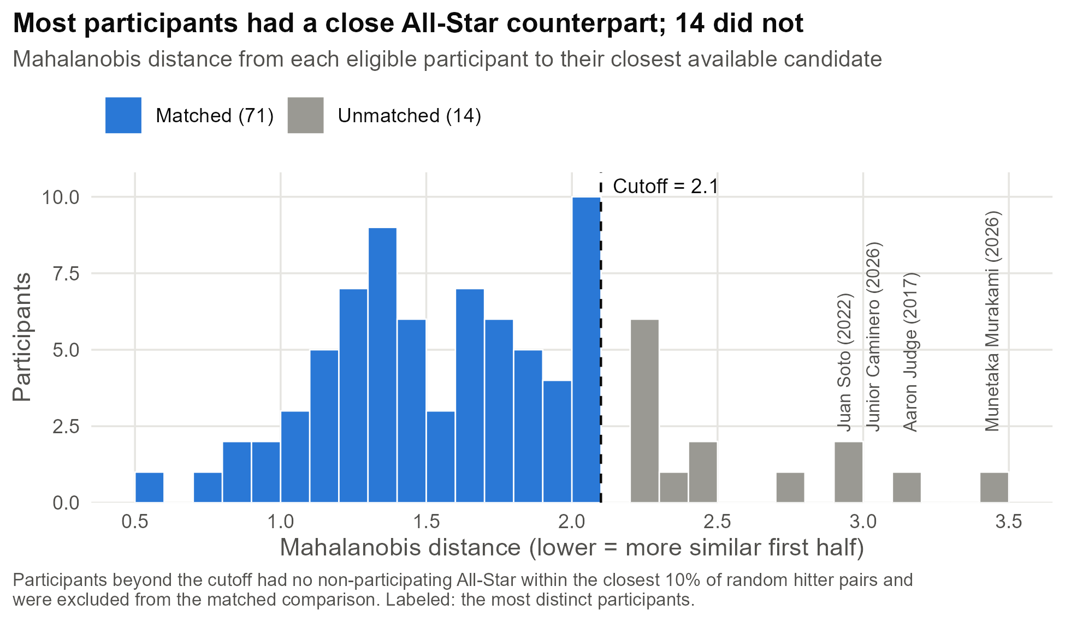
The 14 participants without a match had no available candidate within the cutoff. Most fell just beyond it: six had distances between 2.2 and 2.3, including Prince Fielder in 2015 and Kyle Schwarber in 2022. Others were far more distinct than any available All-Star, most notably Munetaka Murakami in 2026 (3.44), Aaron Judge in 2017 (3.16), Junior Caminero in 2026 (2.98), and Juan Soto in 2022 (2.93). Four of the 14 came from 2026, the season with the fewest matched pairs. Rather than loosen the cutoff and accept poorer comparisons, these participants were excluded from the matched analysis but retained in the within-participant analysis. Because the unmatched group includes several of the most extreme power hitters, the matched results describe the more typical Derby participant.
Matching substantially reduced first-half differences between participants and the candidate pool (Figure 2). Before matching, participants differed most from other All-Stars in HR/FB (SMD = 0.74), K% (0.59), and average exit velocity (0.53), reflecting the power-hitting profile that earns a Derby invitation. After matching, these differences fell to 0.27, 0.20, and 0.18. Pull% fell from 0.37 to 0.22 and FB% from 0.39 to 0.29, while launch angle, which differed little to begin with, was essentially unchanged (0.19). Because FB% remained above the 0.25 threshold and is one component of the Pull-Air Index, the primary analysis adjusts for first-half values rather than relying on matching alone.
Figure 2
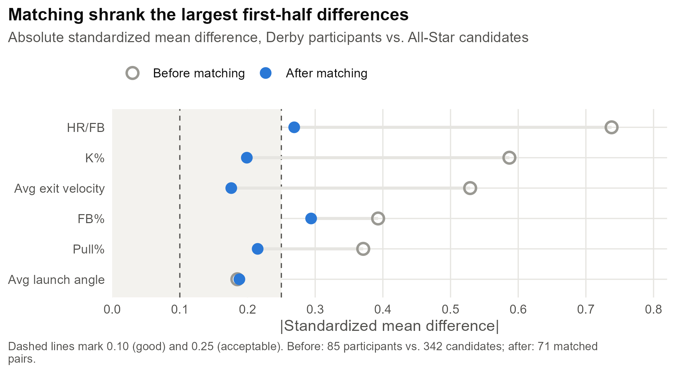
Primary Outcome. Derby participants entered the second half with a higher Pull-Air Index than their matched controls (0.32 vs. 0.07) and increased more after the break, rising to 0.44 compared with 0.10 for controls (Figure 3). After adjusting for first-half values, participants' index increased by 0.11 standard deviations more than controls', but the difference was not statistically significant (β₁ = 0.107, 95% CI [−0.077, 0.292], p = .25). The confidence interval rules out large effects: its upper bound corresponds to an increase of roughly two percentage points in both Pull% and FB%. The increase came from pulling rather than lifting the ball. Participants' Pull% rose from 42.9% to 44.3%, while controls' was essentially unchanged (41.7% to 41.2%); FB% barely moved for participants (40.6% to 40.7%) and rose slightly for controls (38.6% to 39.5%).
Figure 3
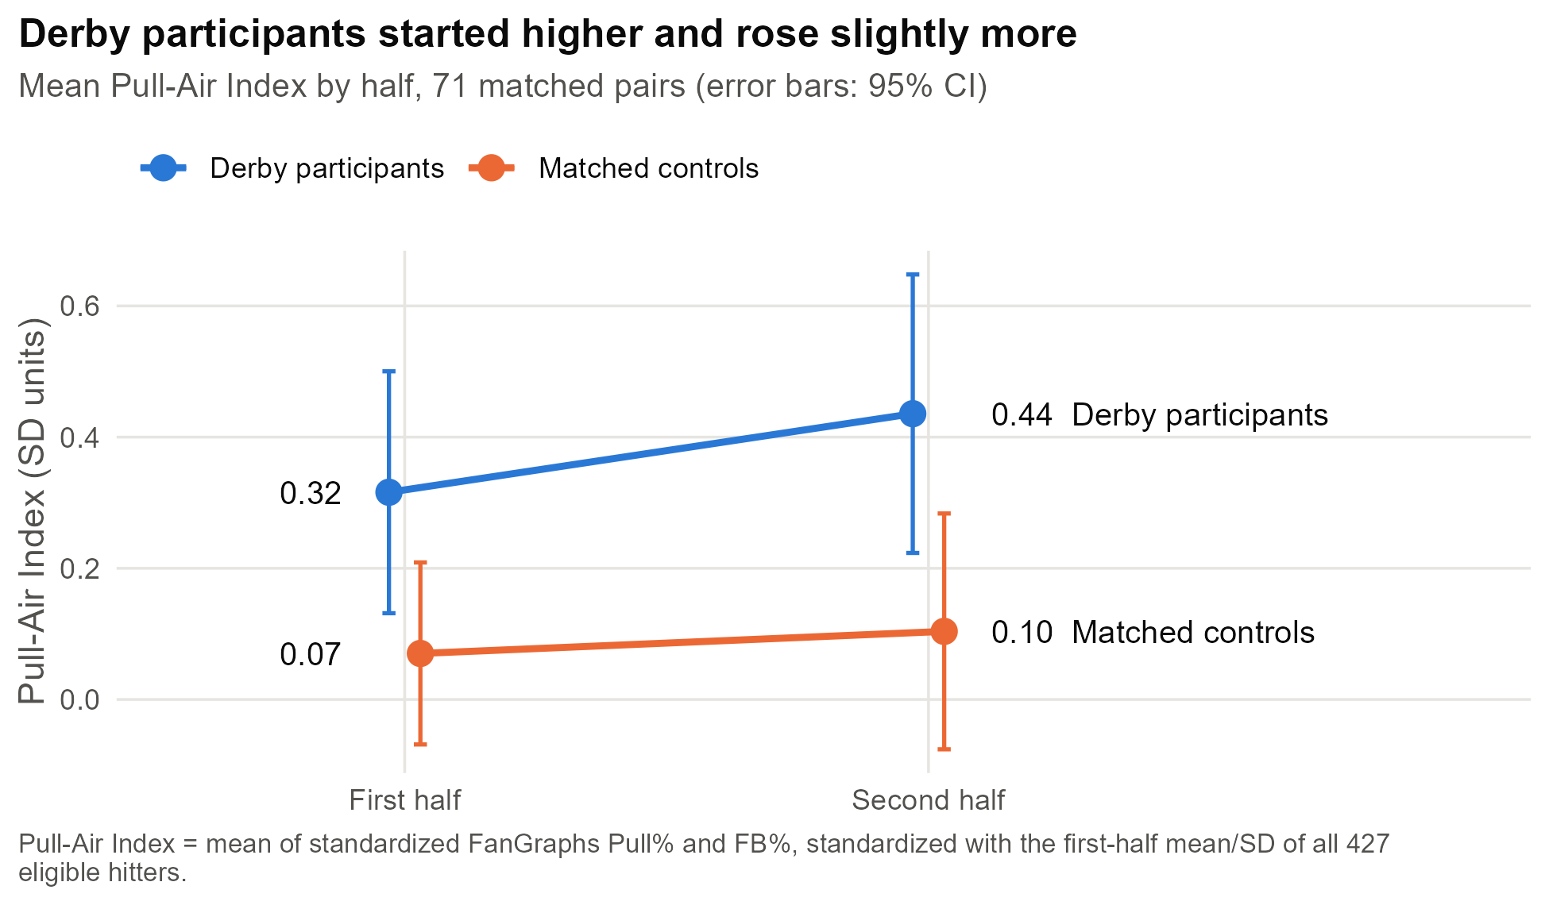
Secondary Outcomes. Home-run direction showed the clearest difference between groups (Figure 4). Participants pulled 57.0% of their first-half home runs and 62.8% of their second-half home runs, while controls moved in the opposite direction, from 59.2% to 56.6%. After adjustment, participants' share of pulled home runs rose by 6.9 percentage points more than controls' (97.5% CI [−0.3, 14.1], p = .031), narrowly missing the Bonferroni-corrected threshold of α = .025. HR/FB declined after the break in both groups, from 20.9% to 19.2% among participants and from 19.5% to 16.4% among controls; the adjusted difference of 1.9 percentage points in participants' favor was also not significant (97.5% CI [−0.3, 4.0], p = .049).
Figure 4
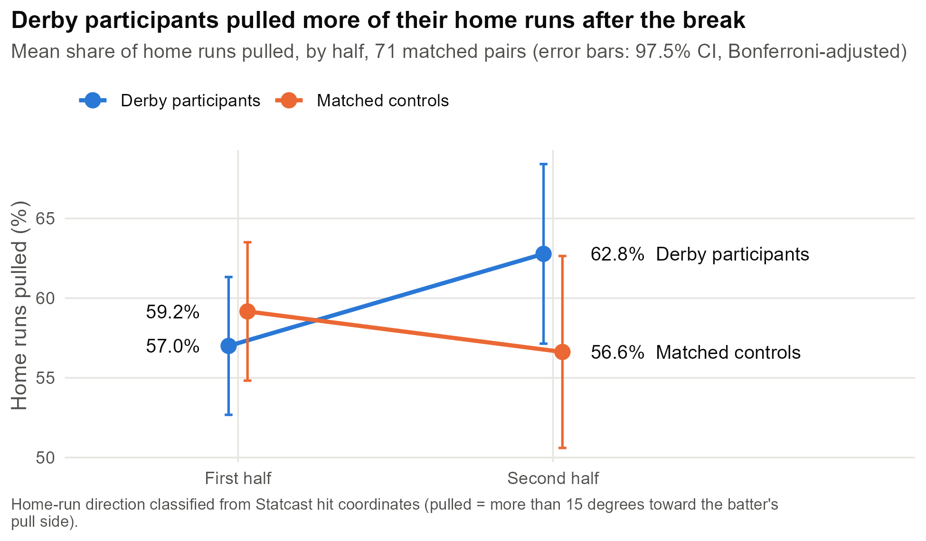
Supporting and Exploratory Analyses. The supporting analyses agreed in direction with the primary result (Figure 5). Within all 85 eligible participants, the Pull-Air Index rose by 0.11 (95% CI [−0.02, 0.23], p = .086), and the unadjusted difference between matched participants and controls was 0.09 (95% CI [−0.10, 0.27], p = .35). Within participants, HR Pull% rose by 5.3 percentage points (97.5% CI [0.4, 10.2], p = .015), the only result to clear its threshold; however, this comparison has no control group and cannot separate an effect of the Derby from changes affecting all hitters after the break. The exploratory ANOVA found no difference in the change in the index across Derby format and participant status, F(3, 138) = 0.76, p = .52, although the swing-based format contributed only four pairs.
Figure 5
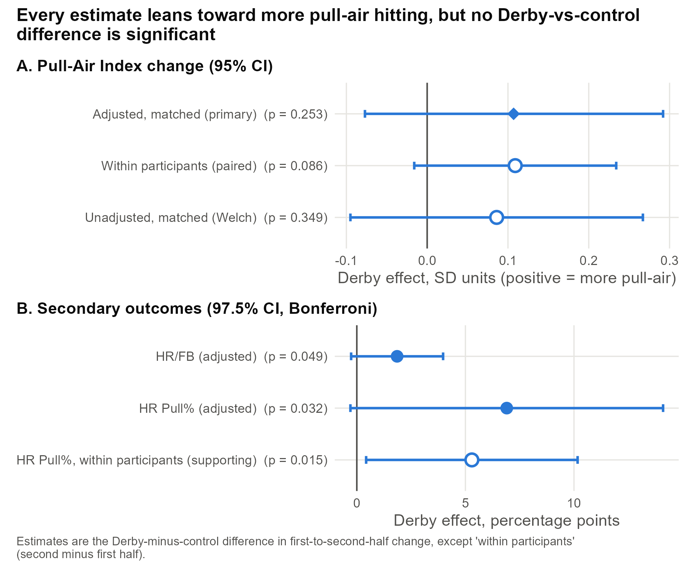
Model Diagnostics and Robustness. Residuals were approximately normal for all three models (Shapiro–Wilk p = .52, .25, and .44 for the Pull-Air Index, HR/FB, and HR Pull% models), and no model showed evidence of nonlinearity (RESET p ≥ .31; Appendix B). The primary model showed no evidence of non-constant variance (Breusch–Pagan p = .73). Variance inflation factors for the Derby term were about 1.0 in every model, so correlations among predictors did not affect its estimate; the high VIFs in the HR/FB model (18.8 and 17.3) arise because the FanGraphs and Statcast versions of first-half HR/FB, correlated at r = .96, appear together as controls. The primary estimate was stable under every robustness check: p = .26 with HC3 standard errors, p = .25 with standard errors clustered by pair, and β₁ = 0.089 (p = .27) after removing nine influential observations. The within-participant changes underlying the supporting paired t-test were also approximately normal (Shapiro–Wilk p = .72).
Both secondary models showed mild non-constant variance (Breusch–Pagan p = .017 for HR/FB and p = .040 for HR Pull%). With HC3 standard errors, neither secondary result reached α = .025 (p = .055 and p = .032). With standard errors clustered by pair, the HR Pull% result fell just below the threshold (p = .024), but because this specification was not chosen in advance and the result does not hold under the other checks, it is not treated as significant. The HR Pull% estimate was also sensitive to influential observations: removing nine flagged players reduced it from 6.9 to 4.3 percentage points (p = .11). These players hit very few second-half home runs; for example, Freddie Freeman hit one home run after the break in 2026, so a single home run determined his entire second-half HR Pull%. Nine matched player-seasons had five or fewer second-half home runs. The HR Pull% result should therefore be interpreted as suggestive and fragile rather than as evidence of an effect.
Discussion
This study asked whether Home Run Derby participation is associated with a shift toward a pull-oriented, fly-ball-heavy approach after the All-Star break. Compared with matched non-participating All-Stars, Derby participants' Pull-Air Index rose slightly more, but the difference was small and not statistically significant. Every estimate, whether primary, secondary, or supporting, pointed in the same direction, toward more pull-oriented hitting, yet none of the comparisons between participants and controls cleared its threshold. The results are therefore consistent with either no effect or a modest one, and the confidence intervals argue against a large change in approach.
The pattern within the index is informative. The small increase came from pulling the ball more often rather than hitting more fly balls, and the clearest group difference appeared in the direction of home runs, which participants pulled more often after the Derby while controls pulled them less often. This is consistent with the mechanism proposed in the Introduction: pulling the ball requires earlier contact, contact depth is linked to attack angle (Giordano et al., 2026), and the margin for timing error at impact is narrow and depends on swing path (Nakashima et al., 2025), so repeated maximal-effort pull swings could plausibly leave a trace on a hitter's timing. However, the home-run result depends on a handful of players with very few second-half home runs and did not survive the robustness checks, so it should be treated as a lead for further study rather than a finding.
These results extend prior work rather than contradict it. Jaiclin and McCollum (2010) attributed much of the apparent post-Derby decline to regression to the mean, and DeFroda et al. (2021) found no significant decline in performance or increase in injury among participants. This study adjusted directly for first-half levels and likewise found no strong evidence of change, now at the level of batted-ball approach rather than outcomes such as OPS. Together, the evidence suggests the Derby “curse” reflects selection and regression to the mean more than a lasting change in how participants hit.
For teams and players weighing whether to participate, these findings offer modest reassurance. There is no evidence of a large shift in approach, although a small increase in pulling cannot be ruled out, and the study could reliably detect only effects of roughly a quarter of a standard deviation or larger.
Limitations. Several limitations apply. First, the design is observational: players are invited based on first-half performance and choose whether to accept, so participants may differ from controls in ways the matching variables do not capture. Second, 14 participants, including several of the most extreme power hitters, had no comparable control, so the matched results may not generalize to the most distinctive sluggers. Third, HR Pull% rests on small per-half samples of home runs, which makes it highly variable. Fourth, the Pull-Air Index averages two separate rates rather than measuring balls that were both pulled and hit in the air. Fifth, the matching variables (Statcast) and outcomes (FanGraphs) come from sources that classify batted balls differently; this separates matching from outcome measurement, but the two sets of measures are not identical. Sixth, several players appear in more than one season, so observations are not fully independent, and the pairing was addressed only through a robustness check. Finally, the swing-based 2026 format contributes only four pairs, too few to compare formats.
Future Work. Several extensions are planned. The 14 unmatched participants will be analyzed with a within-subject comparison of their Derby seasons against their own non-Derby seasons, following Jaiclin and McCollum (2010). A direct pulled-fly-ball rate, computed from Statcast coordinates with the validated classification, would address the main limitation of the Pull-Air Index, and ground-ball and line-drive rates would test whether the increase in pulling reflects more pulled ground balls (“rolling over”) rather than pulled fly balls. Models that weight HR Pull% by the number of home runs would reduce the influence of small samples, and bat-tracking measures such as bat speed and attack angle, available from 2023 onward, could test the proposed timing mechanism directly as more seasons accumulate.
Conclusion. Across 71 matched pairs spanning 11 Derbies, participation in the Home Run Derby was not associated with a statistically significant change in batted-ball approach. Participants pulled the ball slightly more after the break and pulled a larger share of their home runs, but these differences were small, fragile, or both. For now, the evidence suggests that the Derby does not substantially change how hitters hit.

References
Abdi, H., & Williams, L. J. (2010). Tukey's honestly significant difference (HSD) test. In N. J. Salkind (Ed.), Encyclopedia of research design (pp. 1–5). SAGE Publications. https://doi.org/10.4135/9781412961288.n478
Armstrong, R. A. (2014). When to use the Bonferroni correction. Ophthalmic and Physiological Optics, 34(5), 502–508. https://doi.org/10.1111/opo.12131
Barnett, A. G., van der Pols, J. C., & Dobson, A. J. (2005). Regression to the mean: What it is and how to deal with it. International Journal of Epidemiology, 34(1), 215–220. https://doi.org/10.1093/ije/dyh299
Baseball Savant. (n.d.). Statcast search [Data set]. MLB Advanced Media. https://baseballsavant.mlb.com/
Chadwick Baseball Bureau. (n.d.). Chadwick Baseball Bureau register [Data set]. GitHub. https://github.com/chadwickbureau/register
DeFroda, S. F., Staffa, S. J., Keeley, T., & Kriz, P. K. (2021). Home Run Derby participation in Major League Baseball players: Is there associated injury risk and impact on second-half performance? Orthopaedic Journal of Sports Medicine, 9(2), 1–8. https://doi.org/10.1177/2325967120983350
FanGraphs. (n.d.). Splits leaderboards [Data set]. https://www.fangraphs.com/
Giordano, K. A., Jump, I., Lerch, B., & Oliver, G. D. (2026). Contact depth affects most of the other hitting metrics we analyze. Sports, 14(8), Article 330. https://doi.org/10.3390/sports14080330
Jaiclin, M., & McCollum, J. (2010). Home Run Derby curse: Fact or fiction? Baseball Research Journal, 39(2). https://sabr.org/journal/article/home-run-derby-curse-fact-or-fiction/
LeDoux, J. (n.d.). pybaseball [Computer software]. GitHub. https://github.com/jldbc/pybaseball
MLB Advanced Media. (n.d.). MLB Stats API [Data set]. https://statsapi.mlb.com/
Nakashima, H., Horiuchi, G., Kimura, A., & Sakurai, S. (2025). Acceptable range of timing error at bat-ball impact in baseball depends on the bat swing path. Frontiers in Sports and Active Living, 7, Article 1557145. https://doi.org/10.3389/fspor.2025.1557145
Stuart, E. A. (2010). Matching methods for causal inference: A review and a look forward. Statistical Science, 25(1), 1–21. https://doi.org/10.1214/09-STS313

Appendices
Appendix A: Code and Data
All code, data, and figures for this study are hosted in the project's GitHub repository: https://github.com/rollojack/da-401. The repository's code folder contains the scripts in the order they are run: build_control_pool.py (control pool and plate appearances), pull_statcast_halves.py (half-season Statcast metrics), matching.R (matching and balance), build_control_fangraphs.py (control outcome data), hr_spray_statcast.py (home-run direction), build_analysis_dataset.py (analysis dataset), primary_analysis.R (primary, secondary, supporting, and exploratory tests), model_diagnostics.R (assumption checks and robustness), and figures.R (figures). The data folder contains the raw and processed data, including the matched pairs (Matched_Pairs.csv), the unmatched participants (Unmatched_Participants.csv), the test results (Results.csv), and the diagnostics (Model_Diagnostics.csv and Model_Robustness.csv).
Appendix B: Regression Diagnostics
Figure B1 shows residuals against fitted values and normal Q–Q plots for the three adjusted models. Residuals scatter evenly around zero without systematic curvature, and Q–Q points fall close to the diagonal, consistent with the Shapiro–Wilk and RESET results reported in the Results. The secondary models show slightly wider spread at some fitted values, consistent with the mild non-constant variance detected by the Breusch–Pagan test.
Figure B1


